# GIT INSTALLED OR NOT

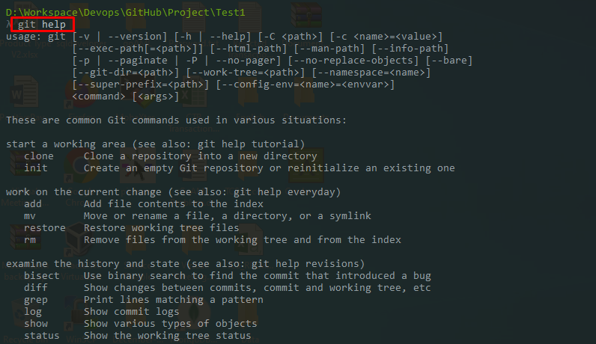# GIT COMMAND LIST

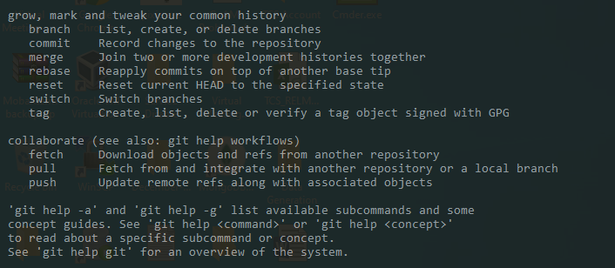

# GIT CONFIGURATION

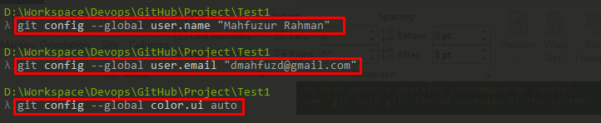

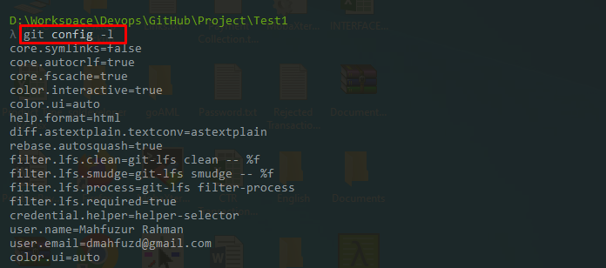

# GIT INIT

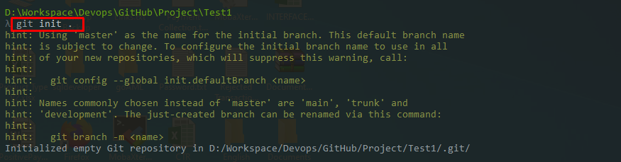

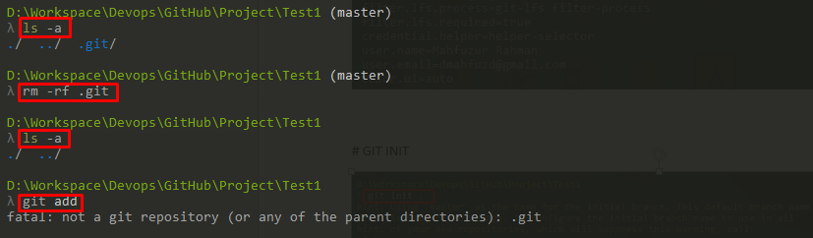

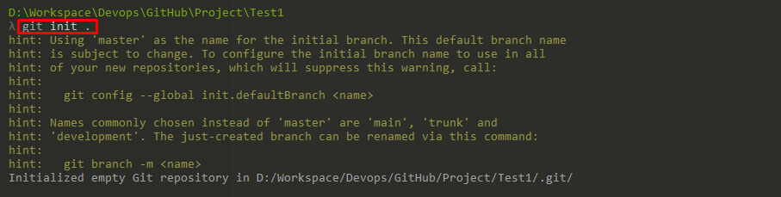

# CREATE FILE

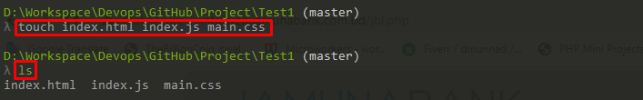

# GIT ADD COMMIT PUSH

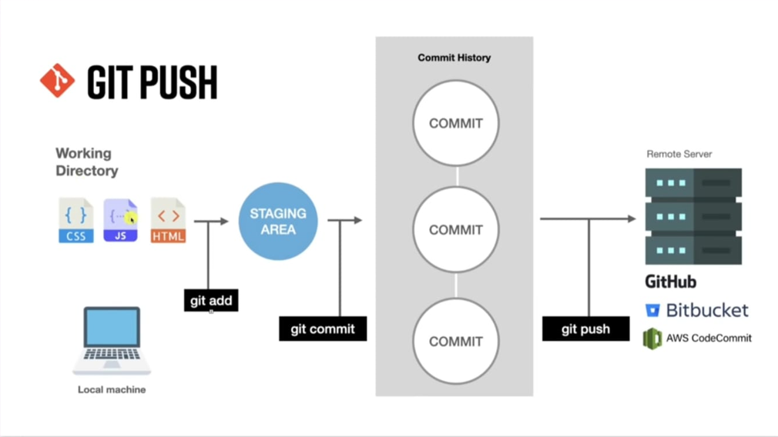

# FILE SEND WORKING DIRECTORY TO STAGING AREA

* git add

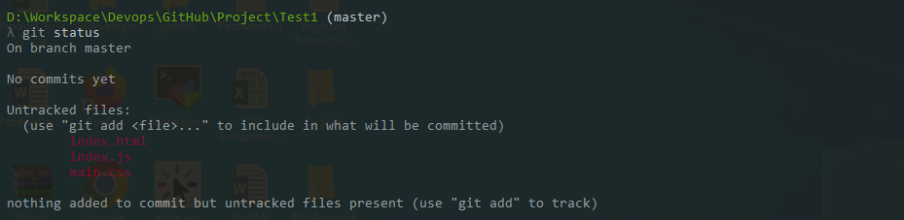

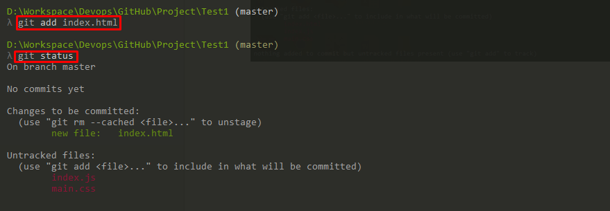

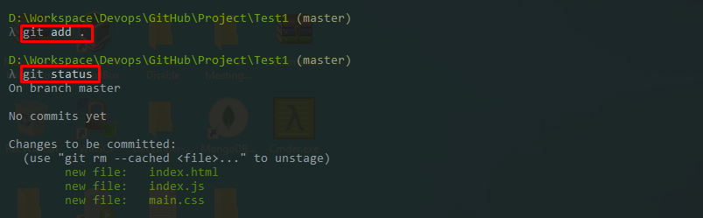Remove Files from Staging Area

